Verse 1
Key: Db major
Intro
V1
C
V2
C
Bridge
C
*Blessed Assurance

Intro: Db • • Gb/Db | 2x
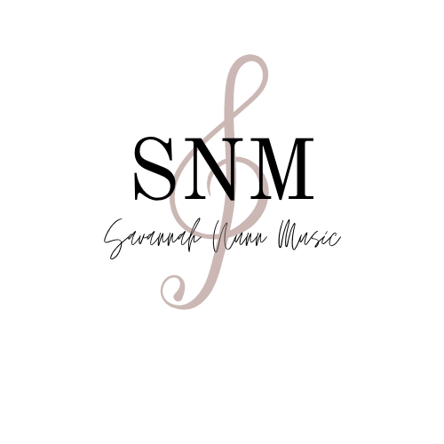
How Saved I Am
Db
I still remember who I used to be
Db/Bb
When this heart cried out to be free
Gb/Eb Db/F Gb Gb/Ab Db • • Gb/Db
I was desperate, a failure, in need of a Savior
Db
I still remember the moment, the time
Db/Bb
When I finally surrendered my life
Gb/Eb Db/F Gb Gb/Ab Ab
I was broken and ran into arms wide open

Chorus
Db
Oh what a difference He made in me
Db/Bb
Because of the blood I’m forgiven and free
Db/Gb Db/F Gb/Eb Db/F Gb Gb/Ab
Everything changed the moment His mercy found me, found me
Db
Now every sin has been traded for grace
Db/Bb
Love came and washed away every stain
Db/Gb Db/F Gb/Eb
So I’ll testify over and over again
Gb Gb/Ab Db
How lost I was, How saved I am

Verse 2
Db
Maybe you’re thinking you’re too far gone
Db/Bb
You can’t get to the cross from the road that you’re on
Gb/Eb Db/F Gb Gb/Ab
But He’ll find you, right there, trust me, I’ve been there
Chorus

Bridge
B Gb Db
I’m praising my Savior all the day long
B Gb Absus - Ab
This is my story, this is my song

Chorus
How Saved I Am

*Blessed Assurance
Db Gb/Db
this is my story
Db
This is my song
Gb/Eb Gb/Ab
Praising my Savior
Ab7 Db
All the day long

